04/11/2019

|  |
| --- |
|  |

|  |  |
| --- | --- |
| PROJECT | BOOK MANAGEMENT SYSTEM |



**Name –** RITESH TIWARI

**Roll No -** S02201916

**Course –** CSE

**Project Name-** Book Management System

**Software use**

Turbo C++, Snipping Tool, MS Word, Windows 10

**Hardware use**

Mouse, Keyboard, printer, CD;

Contents

Acknowledgement 4

Book Management System 5

MAIN MENU 6

INSERT MENU 8

SEARCH MENU 9

DEELETE MENU 11

CREATE BOOKS RECORDS 13

BOOK RECORDS 15

SEARCH BY BOOK ID 16

SEARCH BY BOOK NAME 18

INSERT FIRST POSITION 20

INSERT INTO MIDDLE POSITION 22

INSERT INTO LAST POSITION 24

DELETE FIRST RECORD 26

DELETE LAST RECORD 27

DELETE MIDDLE RECORDS 28

# Acknowledgement

I would like to thank my teacher Anand sir a lot for giving me this opportunity to create such an educational project. This project **(Book Management System)** has given me a lot to learn about **Data Structure in C Language**. I would also like to thank my parents heartily because without their help this project could not be successful. I hope to make such an enlightening project in future also.

Thank you

# Book Management System

#include<conio.h>

#include<stdio.h>

#include<stdlib.h>

#include<dos.h>

#include<string.h>

typedef struct book

{

int book_id;

char book_name [100];

char author_name[100];

char publication[100];

char edition [100];

char date_issue [100];

int isbn_no;

struct book *next;

}b;

b *start;

void create (b *);

void display (b *);

b *insert_1st();

void insert_middle ();

void insert_last ();

b *delete_1st ();

void delete_middle ();

void delete_last ();

void modify ();

void search_book_id ();

void search_book_name();

void display1(b *);

## MAIN MENU

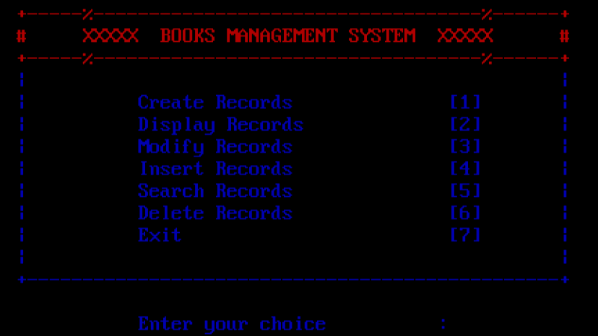

void main(){

int a; clrscr();

start=(b *)malloc(sizeof(b));

do{

clrscr();

textcolor(RED); printf("\n\t\t");

cprintf("+-----%-----------------------------------%------+"); printf("\n\t\t");

cprintf("# XXXXX BOOKS MANAGEMENT SYSTEM XXXXX # ");

printf("\n\t\t"); cprintf("+-----%-----------------------------------%------+");

textcolor(BLUE);

printf("\n\t\t"); cprintf("| |");

printf("\n\t\t"); cprintf("| Create Records [1] |");

printf("\n\t\t"); cprintf("| Display Records [2] |");

printf("\n\t\t"); cprintf("| Modify Records [3] |");

printf("\n\t\t"); cprintf("| Insert Records [4] |");

printf("\n\t\t"); cprintf("| Search Records [5] |");

printf("\n\t\t"); cprintf("| Delete Records [6] |");

printf("\n\t\t"); cprintf("| Exit [7] |");

printf("\n\t\t"); cprintf("| |");

printf("\n\t\t"); cprintf("+------------------------------------------------+");

printf("\n\n\t\t");cprintf(" Enter your choice :");

cscanf("%d",&a);

clrscr();

switch(a)

{

case 1: create(start); break;

case 2: display(start); break;

//case 3: modify(); break;

case 4:

INSERT MENU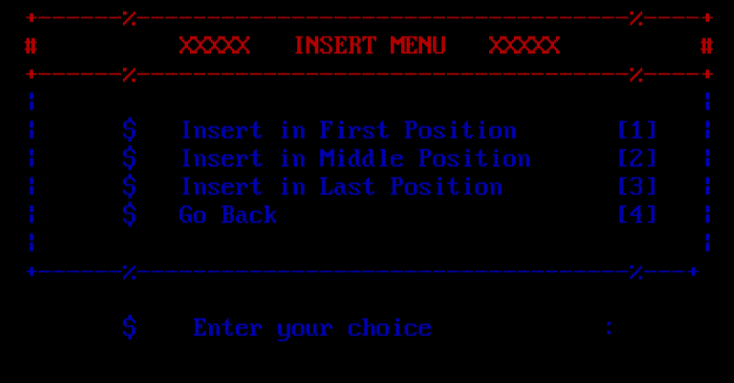

clrscr();

textcolor(RED);

printf("\n\t\t");

cprintf("+------%-----------------------------------%----+");

printf("\n\t\t");

cprintf("# XXXXX INSERT MENU XXXXX #");

printf("\n\t\t");

cprintf("+------%-----------------------------------%----+");

textcolor(BLUE);

printf("\n\t\t"); cprintf("| |");

printf("\n\t\t"); cprintf("| $ Insert in First Position [1] |");

printf("\n\t\t"); cprintf("| $ Insert in Middle Position [2] |");

printf("\n\t\t"); cprintf("| $ Insert in Last Position [3] |");

printf("\n\t\t"); cprintf("| $ Go Back [4] |");

printf("\n\t\t"); cprintf("| |");

printf("\n\t\t"); cprintf("+------%-----------------------------------%---+");

printf("\n\n\t\t $ Enter your choice :");

scanf("%d",&a);

switch(a)

{

case 1: clrscr(); start=insert_1st(); break;

case 2: clrscr(); insert_middle(); break;

case 3: clrscr(); insert_last(); break;

case 4: clrscr(); break;

default : printf("\n You pressed the wrong option, please try again!\n");

}

break;

case 5:

SEARCH MENU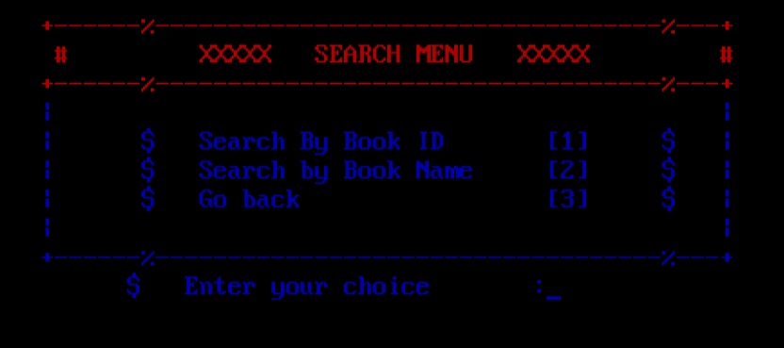

clrscr();

textcolor(RED);

printf("\n\t\t"); cprintf("+------%-----------------------------------%---+");

printf("\n\t\t"); cprintf(" # XXXXX SEARCH MENU XXXXX #");

printf("\n\t\t"); cprintf("+------%-----------------------------------%---+");

textcolor(BLUE);

printf("\n\t\t"); cprintf("| |");

printf("\n\t\t"); cprintf("| $ Search By Book ID [1] $ |");

printf("\n\t\t"); cprintf("| $ Search by Book Name [2] $ |");

printf("\n\t\t"); cprintf("| $ Go back [3] $ |");

printf("\n\t\t"); cprintf("| |");

printf("\n\t\t"); cprintf("+------%-----------------------------------%---+");

printf("\n\t\t $ Enter your choice :");

scanf("%d",&a);

switch(a)

{

case 1: clrscr();

search_book_id();

break;

case 2: clrscr();

search_book_name();

break;

case 3: clrscr();

break;

default: printf("\n You pressed the wrong option, please try again!\n");

}

break;

case 6:

DEELETE MENU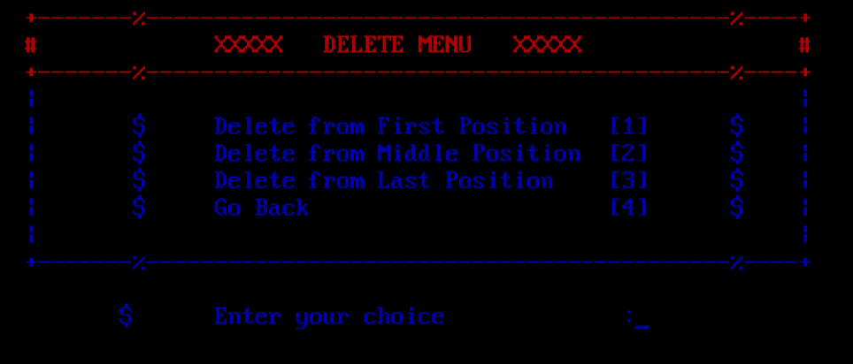

clrscr();

textcolor(RED);

printf("\n\t\t"); cprintf("+-------%-------------------------------------------%----+");

printf("\n\t\t"); cprintf("# XXXXX DELETE MENU XXXXX #");

printf("\n\t\t"); cprintf("+-------%-------------------------------------------%----+");

textcolor(BLUE);

printf("\n\t\t"); cprintf("| |");

printf("\n\t\t"); cprintf("| $ Delete from First Position [1] $ |");

printf("\n\t\t"); cprintf("| $ Delete from Middle Position [2] $ |");

printf("\n\t\t"); cprintf("| $ Delete from Last Position [3] $ |");

printf("\n\t\t"); cprintf("| $ Go Back [4] $ |");

printf("\n\t\t"); cprintf("| |");

printf("\n\t\t"); cprintf("+-------%-------------------------------------------%----+");

printf("\n\n\t\t $ Enter your choice :");

scanf("%d",&a);

switch(a)

{

case 1: clrscr();

start=delete_1st();

break;

case 2: clrscr();

delete_middle();

break;

case 3: clrscr();

delete_last();

break;

case 4: clrscr();

break;

default: printf("\nYou pressed the wrong option, please try again!\n");

}

break;

case 7:

exit(0);

default:

printf("\n You pressed the wrong option, please try again!\n");

}

}while(1);

}

## CREATE BOOKS RECORDS

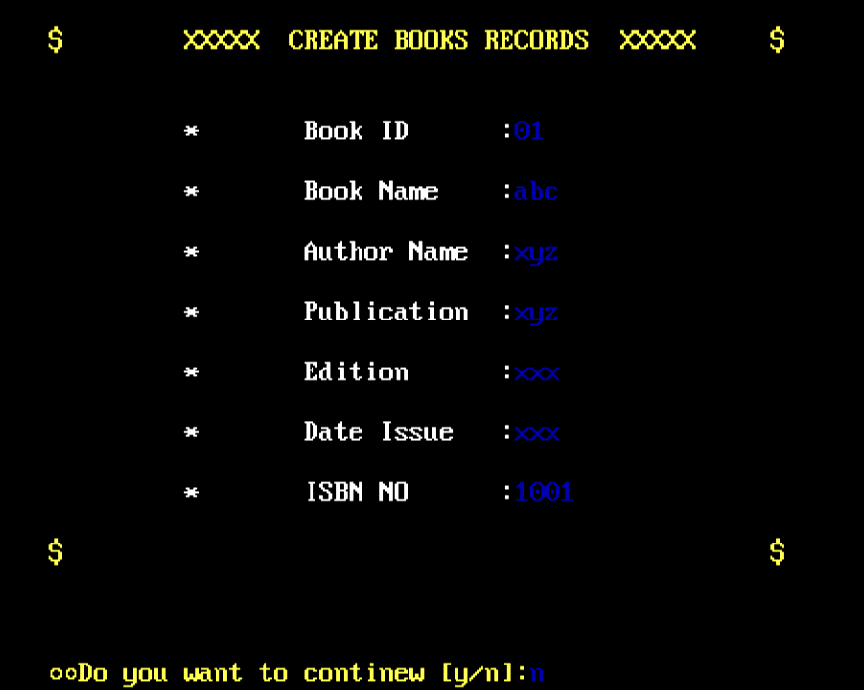

void create(b *node)

{

char ans='y';

while(1)

{

clrscr();

textcolor(YELLOW);

printf("\n\n\n\t\t");

cprintf("$ XXXXX CREATE BOOKS RECORDS XXXXX $");

printf("\n\n\n\t\t");

textcolor(WHITE);

node->next=(b *)malloc(sizeof(b));

cprintf(" * Book ID :"); scanf("%d",&node->book_id);

printf("\n\t\t"); cprintf(" * Book Name :");

fflush(stdin); gets(node->book_name);

printf("\n\t\t"); cprintf(" * Author Name :");

fflush(stdin); gets(node-> author_name);

printf("\n\t\t"); cprintf(" * Publication :");

fflush(stdin); gets(node->publication);

printf("\n\t\t"); cprintf(" * Edition :");

fflush(stdin); gets(node->edition);

printf("\n\t\t"); cprintf(" * Date Issue :");

fflush(stdin); gets(node->date_issue);

printf("\n\t\t"); cprintf(" * ISBN NO :");

scanf("%d",&node->isbn_no);

printf("\n\t\t");

textcolor(YELLOW);

cprintf("$ $");

printf("\n\n\t\t"); cprintf(" Do you want to continue [Y/N]:");

fflush(stdin); ans=getchar();

if(ans=='y' || ans=='Y')

{ node=node->next; }

else { node->next='\0'; break; }

}

}

## BOOK RECORDS

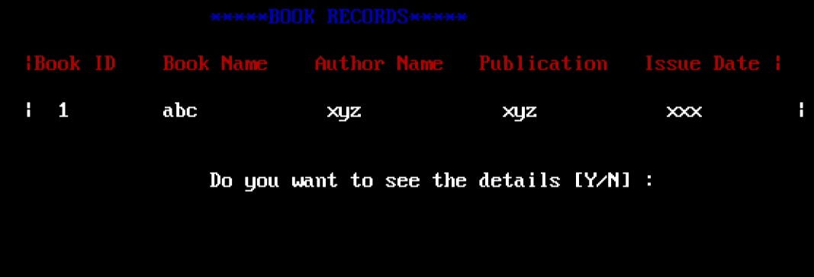

void display(b *node)

{

int no=0;

char n;

clrscr();

printf("\n\t\t\t*****BOOK RECORDS*****\n\n\t");

textcolor(RED);

cprintf("|Book ID Book Name Author Name Publication Issue Date |\n");

while(node)

{

textcolor(WHITE);

printf("\n\t");

cprintf("| %d %s %s %s %s |",node->book_id,node->book_name,node->author_name,node->publication,node->date_issue);

node=node->next;

no++;

}

printf("\n\t\t\t");

cprintf("Do you want to see the details [Y/N] :");

fflush(stdin);

n=getchar();

if(n=='y'||n=='Y')

{ printf("\n\t\t\t"); search_book_id(); return; }

textcolor(RED+BLINK); printf("\n");

cprintf("Press Enter!") getch();

}

## SEARCH BY BOOK ID

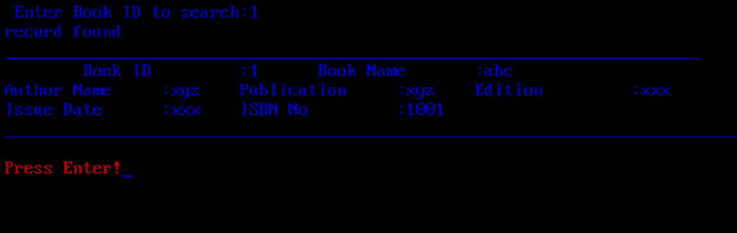

void search_book_id()

{

b *node,*temp;

int nod;

node=start;

temp=start;

printf("\n Enter Book ID to search:");

scanf("%d",&nod);

while(node)

{

if(temp->book_id==nod)

{

printf("record found");

printf("\n_______________________________________________________________________\n");

printf("\tBook ID \t:%d",node->book_id);

printf("\tBook Name \t:%s\n",node->book_name);

printf("Author Name\t:%s",node->author_name);

printf("\tPublication \t:%s",node->publication);

printf("\tEdition\t\t:%s\n",node->edition);

printf("\Issue Date \t:%s",node->date_issue);

printf("\tISBN No\t\t:%d",node->isbn_no);

printf("\n_________________________________________________________________________\n");

getch();

break;

}

else { printf("Record Not found"); break; }

node=node->next;

}

textcolor(RED+BLINK);

printf("\n");

cprintf("Press Enter!");

getch();

}

## SEARCH BY BOOK NAME

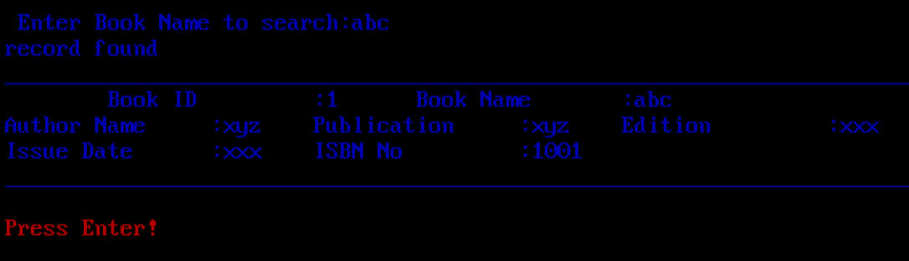

void search_book_name()

{

b *node;

char name[100];

node=start;

printf("\n Enter Book Name to search:");

fflush(stdin);

gets(name);

while(node)

{

if(strcmp(node->book_name,name)==0)

{

printf("\n_______________________________________\n");

printf("\tBook ID \t:%d",node->book_id);

printf("\tBook Name \t:%s\n",node->book_name);

printf("Author Name\t:%s",node->author_name);

printf("\tPublication \t:%s",node->publication);

printf("\tEdition\t\t:%s\n",node->edition);

printf("\tIssue Date \t:%s",node->date_issue);

printf("\tISBN No\t\t:%d",node->isbn_no);

printf("\n__________________________________________\n");

getch();

break;

}

else

{

printf("Record Not found");

break;

}

node=node->next;

}

textcolor(RED+BLINK);

printf("\n");

cprintf("Press Enter!");

getch();

}

## INSERT FIRST POSITION

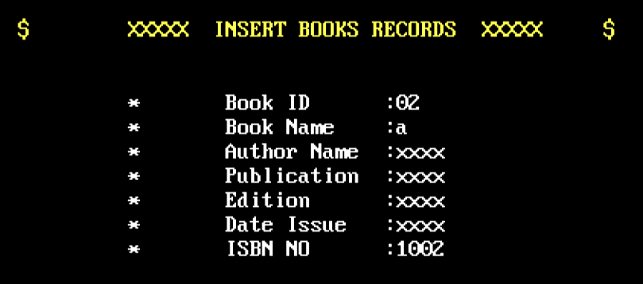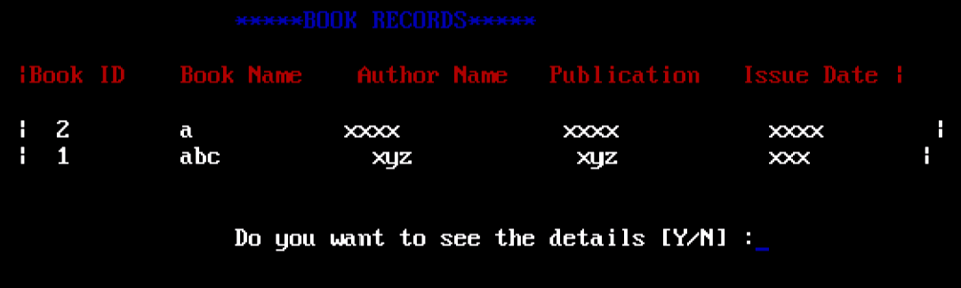

b *insert_1st()//b *insert_1st()

{

b *node,*new1;

node=start;

new1=(b *)malloc(sizeof(b));

new1->next=node;

textcolor(YELLOW);

printf("\n\n\n\t\t");

cprintf("$ XXXXX INSERT BOOKS RECORDS XXXXX $");

printf("\n\n\n\t\t");

textcolor(WHITE);

cprintf(" * Book ID :"); cscanf("%d",&new1->book_id);

printf("\n\t\t"); cprintf(" * Book Name :");

fflush(stdin); gets(new1->book_name);

printf("\n\t\t"); cprintf(" * Author Name :");

fflush(stdin); gets(new1->author_name);

printf("\n\t\t"); cprintf(" * Publication :");

fflush(stdin); gets(new1->publication);

printf("\n\t\t"); cprintf(" * Edition :");

fflush(stdin); gets(new1->edition);

printf("\n\t\t"); cprintf(" * Date Issue :");

fflush(stdin); gets(new1->date_issue);

printf("\n\t\t"); cprintf(" * ISBN NO :");

cscanf("%d",&new1->isbn_no);

printf("\n\t\t");

textcolor(YELLOW);

cprintf("$ XXXXXXXXXXXXXXXXXXXXXXXXXXXXXXXXXX $");

start=new1;

return start;

}

INSERT INTO MIDDLE POSITION 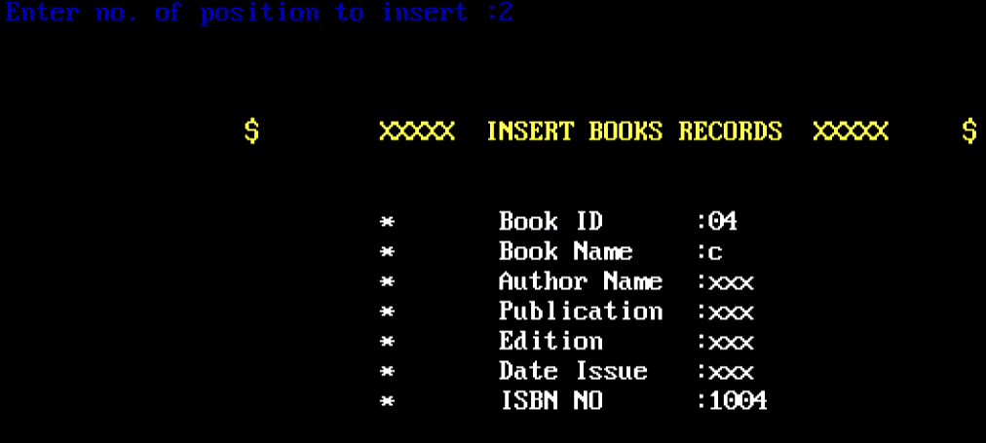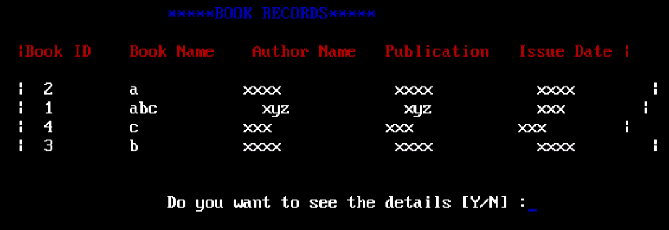

void insert_middle()

{

b *prev,*node,*new1;

int no=0,p=0;

prev=start;

node=start->next;

printf("Enter no. of position to insert :");

scanf("%d",&p);

while(node)

{

no++;

if(no==p)

{

new1=(b *)malloc(sizeof(b));

textcolor(YELLOW);

printf("\n\n\n\t\t");

cprintf("$ XXXXX INSERT BOOKS RECORDS XXXXX $");

printf("\n\n\n\t\t");

textcolor(WHITE);

cprintf(" * Book ID :");

cscanf("%d",&new1->book_id);

printf("\n\t\t"); cprintf(" * Book Name :");

fflush(stdin); gets(new1->book_name);

printf("\n\t\t"); cprintf(" * Author Name :");

fflush(stdin); gets(new1->author_name);

printf("\n\t\t"); cprintf(" * Publication :");

fflush(stdin); gets(new1->publication);

printf("\n\t\t"); cprintf(" * Edition :");

fflush(stdin); gets(new1->edition);

printf("\n\t\t"); cprintf(" * Date Issue :");

fflush(stdin); gets(new1->date_issue);

printf("\n\t\t");

cprintf(" * ISBN NO :");

cscanf("%d",&new1->isbn_no);

printf("\n\t\t");

textcolor(YELLOW);

cprintf("$ XXXXXXXXXXXXXXXXXXXXXXXXXXXXXXXXXX $");

new1->next=node;

prev->next=new1;

break;

}

else { prev=prev->next; node=node->next; }

}

}

## INSERT INTO LAST POSITION

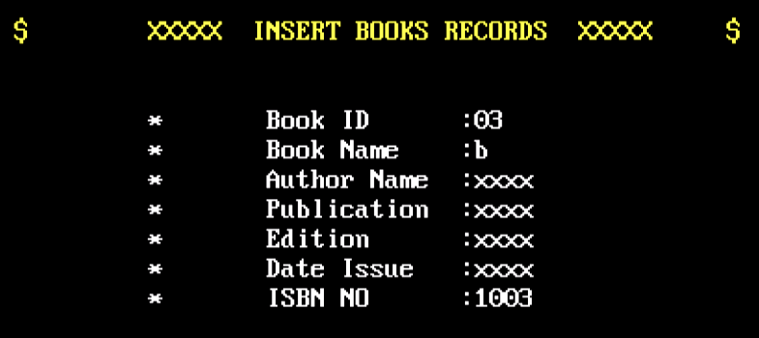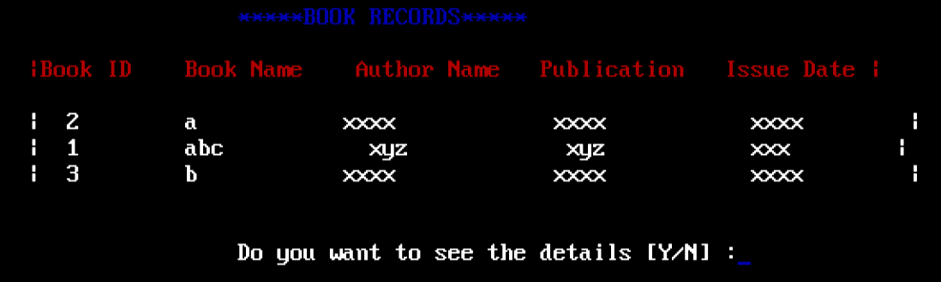

void insert_last()

{

b *node,*new1,*prev;

prev=start;

node=start->next;

while(node)

{ node=node->next; prev=prev->next; }

if(node==NULL)

{

new1=(b *)malloc(sizeof(b));

new1->next=node;

prev->next=new1;

textcolor(YELLOW);

printf("\n\n\n\t\t");

cprintf("$ XXXXX INSERT BOOKS RECORDS XXXXX $");

printf("\n\n\n\t\t");

textcolor(WHITE);

cprintf(" * Book ID :");

cscanf("%d",&new1->book_id);

printf("\n\t\t"); cprintf(" * Book Name :");

fflush(stdin); gets(new1->book_name);

printf("\n\t\t"); cprintf(" * Author Name :");

fflush(stdin); gets(new1->author_name);

printf("\n\t\t"); cprintf(" * Publication :");

fflush(stdin); gets(new1->publication);

printf("\n\t\t"); cprintf(" * Edition :");

fflush(stdin); gets(new1->edition);

printf("\n\t\t"); cprintf(" * Date Issue :");

fflush(stdin); gets(new1->date_issue);

printf("\n\t\t");

cprintf(" * ISBN NO :");

cscanf("%d",&new1->isbn_no);

printf("\n\t\t");

textcolor(YELLOW);

cprintf("$ XXXXXXXXXXXXXXXXXXXXXXXXXXXXXXXXXX $");

}

}

## DELETE FIRST RECORD

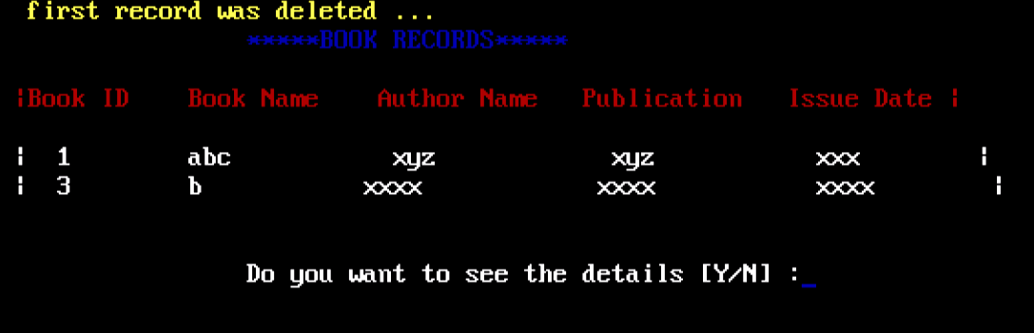

b *delete_1st()

{

b *node;

clrscr();

node=start;

start=node->next;

free(node);

textcolor(YELLOW);

cprintf(“\t\t”);

printf(" 1st Position record was deleted...");

display(start);

getch();

return start;

}

## DELETE LAST RECORD

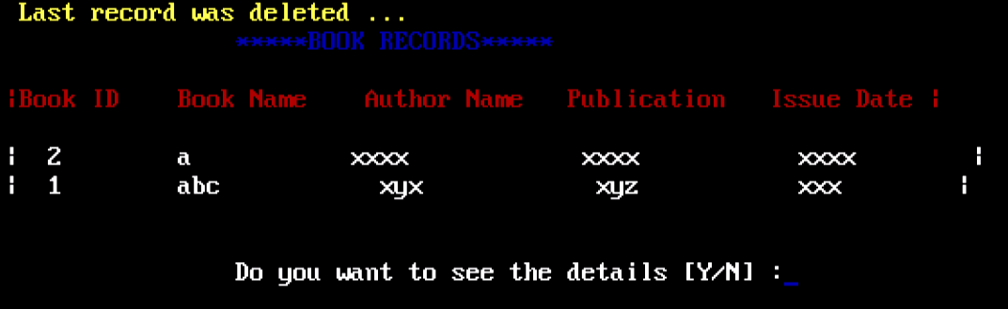

void delete_last()

{

b *prev, *node;

clrscr();

node=start;

prev=start;

while(node)

{

if(node->next==NULL)

{ prev->next=node->next; free(node); break; }

else { prev=node; node=node->next; }

}

textcolor(YELLOW);

printf(“\t\t”);

cprintf("Last record was deleted ...");

display(start);

getch();

}

## DELETE MIDDLE RECORDS

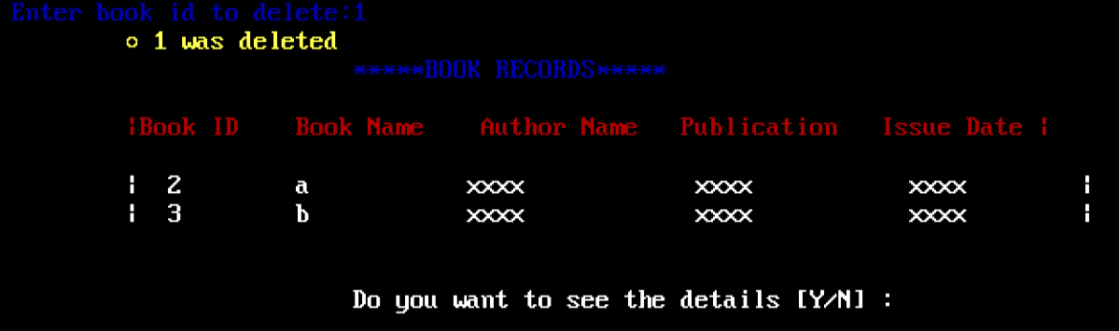

void delete_middle()

{

b *prev ,*node;

int no=1,nod=0;

clrscr();

prev=start;

node=start->next;

printf("Enter book id to delete:");

scanf("%d",&nod);

while(node)

{

if(node->book_id==nod)

{ prev->next=node->next; free(node); break; }

prev=prev->next; node=node->next; no++;

}

textcolor(YELLOW);

printf(“\t\t”);

cprintf("%d was deleted",nod);

display(start);

getch();

}